EXOTIC ADOPTION: GROWING UP BLACK IN A WHITE FAMILY

Dr. Catana Tully reveals how to break free from the burden of having been adopted into a blended family

Dr. Catana Tully’s incredible story shows how an exotic child adopted into a White family learned to overcome painful racial confusion, misplaced identity, poor self-image, and fear of abandonment to lead a meaningful and significant life.  Today the retired college professor is the bestselling author of Split at the Root: A Memoir of Love and Lost Identity. After retiring from her position of tenured college professor, she has dedicated herself to addressing the pressing issues adult exotic adoptees, and parents who have or are planning to adopt interracially, face on a daily basis. She offers words of wisdom and tools to strengthen their impaired images of themselves, their race, their religion, and their culture.  Possible Show/ Story Ideas  - How not to objectify your adopted child.  - Your adopted child is upset with the world: do you know why?  - My life before you: Why an adopted child’s heritage matters.  - Why adopted children resent their new parents.  - My child gained a new family: Why is there a sense of loss?  - Lingering self-doubts: How the birthparents affect the adoptee’s self-image.  - The perpetual child: How to recognize childlike behavior in the adult adoptee.  - It’s not about you! How adoptive parents should focus on the child.  - How can I explain why I can’t truly love my adoptive parents?  Testimonials:  1 – Catana Tully’s book is a piece of seminal instruction to those involved in the adoption process, especially parents of children whose race or cultural background is substantially different than that of the adopting parents. This is essential reading for all considering such adoptions. – Kingston Nyamapfene, VP, IUBG, Grand Bassam, Cote d’Ivoire  2 - Equally comfortable at home or abroad, her multi-lingual, multi-cultural talents are a distinct plus and her effervescent personality a true delight. - Gavin Lowder, Director Ctr. Internat. Progr. Empire State College  3 - Catana was an excellent person to work with, communicative, fair and very thorough. She was widely respected, as an academic and as an administrator, by students and faculty alike. I learnt a great deal from her about teaching and about mentoring students. Tanweer Ali, Lecturer Empire State College  Availability: Nationwide by arrangement via telephone and skype  Contact: Catana Tully, 928-284-9477 catana@splitattheroot.com | 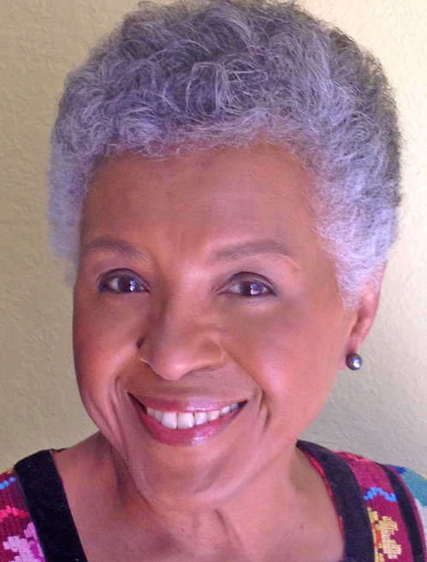
 | Catana Tully
 | 